
Earth’s future
Supporting Information for
Potential influences of volcanic eruptions on future global land monsoon precipitation changes
Wenmin Man*^{1,2}, Meng Zuo¹, Tianjun Zhou^{1,2,3}, John T. Fasullo⁴, Ingo Bethke⁵, Xiaolong Chen^{1,2}, Liwei Zou^{1,2}, Bo Wu^{1,2}

- LASG, Institute of Atmospheric Physics, Chinese Academy of Sciences, Beijing, China
- CAS Center for Excellence in Tibetan Plateau Earth Sciences, Chinese Academy of Sciences, Beijing, China
- University of Chinese Academy of Sciences, Beijing, China
- National Center for Atmospheric Research, Boulder, CO, USA
- Geophysical Institute, Bjerknes Centre for Climate Research, University of Bergen, Bergen, Norway

Contents of this file
Text S1 to S3
Tables S1 to S2
Figures S1 to S9

Text S1. Volcanic forcing generation and implementation.
This section summarizes the generation and implementation of the future volcanic forcing applied in this study. Further details are presented in the online methods of Bethke et al. (2017).
Utilising sulfate records in multiple ice cores from Greenland and Antarctica, Sigl et al. (2015) reconstructed the explosive volcanic activity of the past 2,500 years (Supplementary Figure S8, top panel). Their reconstruction provides information on eruption onset timing, amount of sulfur injection, and location (tropical vs NH/SH extratropical, derived from relative sulfate load in Greenland versus Antarctic cores) of in total 283 detected eruption events.
Resampling the reconstructed volcanic activity from Sigl et al. (2015), Bethke et al. (2017) generated sixty plausible 21st Century volcanic eruption chronologies with realistic statistics (Supplementary Figure S8, lower panels). For each month in 2006–2099 and each of the sixty forcing members, they draw random numbers to test whether one or more of the 283 events are tiggered, assuming a constant eruption probability of 1/(2500x12) that is equivalent to a return period of 2,500 years. By design, the statistics of the stochastic eruption chronologies, that Bethke et al. (2017) verified with their Supplement Figure 2, converge against those of the historical reconstruction for increasing number of members. Other resampling variants, such as selecting (with replacement) a random month of the reconstructed eruption chronology or randomly selecting 100-year chunks from the reconstruction, are expected to produce similar results.
The eruption chronologies provide information on onset timing, total stratospheric volcanic aerosol load and whether the eruptions were tropical or NH/SH extratropical. To translate this information into time-latitude-height dependent aerosol concentation forcing for the CMIP5-generation NorESM1-M, Bethke et al. (2017) analysed the models twentieth century forcing data set that was originally constructed by Ammann et al. (2003), who used a transport model to estimate the spatio-temporal dispersal of stratospheric volcanic aerosols. The analysis by Bethke et al. (2017) approximates the dispersion evolution in the data with three spatiotemporal shape functions (for tropical and NH/SH extratropical eruptions) that only depend on latitude, pressure and time since onset and are normalized using the peak global stratospheric volcanic aerosol load (Supplementary Figure S9). The approximation reproduces well the original Ammann et al. (2003) forcing but does not include seasonal effects on dispersal of volcanic aerosols. Bethke et al. (2017) derived the final model forcing by scaling the shape functions with the global aerosol load from the aforementioned eruption chronologies and superposing the result.
Note that for CMIP6-genaration Earth system models, the Easy Volcanic Aerosol forcing generator (Toohey et al., 2016) can readily translate the eruption chronologies into optical volcanic forcing that can be used to drive the models. The resulting spatiotemporal forcing evolutions (not shown) are similar to those obtained by Bethke et al. (2017), but feature a wider tail and less pronounce peak.

Text S2. Time of emergence analysis.
To quantify the impact of plausible volcanic forcing on global land monsoon (GLM) precipitation projections, the ToE analysis is used following Zhang and Delworth(1). We refer to a change in GLM precipitation as “distinguishable” if the change lies outside the range of internal climate variability. “Signal” in this analysis is calculated as ensemble-mean, decadal-mean GLM precipitation anomaly relative to the base period of 1995-2014. Internal climate variability is estimated from the control simulation with a Monte Carlo approach at each grid point. We first randomly select a 10-year period (to mimic any decade in the period 2000-2099) and a second non-overlapping 20-year period (to mimic 1995-2014), and then compute the difference between the time-mean of the 10-year period and the 20-year period—this difference results only from internal climate variability. We repeat this N times to form the grand ensemble of these differences and compute the ensemble average. The value of N generally takes the number of ensemble members. We then repeat the above process 5000 times to create a distribution of such ensemble-mean differences that occur from internal climate variability.

Text S3. The proportion of each type of uncertainty.
To measure the contribution of different type of uncertainty in GLM precipitation projections, we show the proportion of uncertainty due to the episodic volcanic forcing and internal climate variability using the method proposed by Hawkins and Sutton (2009, 2011) with some modification (Fig. S1). The GLM precipitation ensemble mean relative to 1995-2014 in VOLC represents the response to the external forcing. This is different from the Hawkins and Sutton (2009, 2011) in which the external forcing is fitted using ordinary least square with a fourth-order polynomial over 1950-2100. The internal climate variability (I) is defined as the variance of the residuals of each member from the ensemble mean. The uncertainty arisen from volcanic forcing (V) is defined as the variance between the ensemble mean of the VOLC and NO-VOLC members. We present the proportion of the total standard deviation due to these two sources of uncertainty in Fig. S1.
The total standard deviation $\sqrt{T(t)}$ is calculated as:
$\sqrt{T(t)}=\sqrt{I(t)+V(t)}=\frac{\sqrt{I(t)}}{B}+\frac{\sqrt{V(t)}}{B}$ (1)
Where the scaling factor B is:
$B=\frac{\sqrt{I\left(t\right)}+\sqrt{V\left(t\right)}}{\sqrt{T\left(t\right)}}$ (2)
In Fig. S1, the boundaries between the different colored sections are at $\frac{±\sqrt{V\left(t\right)}}{B}$ and $\frac{±(\sqrt{I\left(t\right)}+\sqrt{V\left(t\right)})}{B}$.

Tables
Table S1: Summer precipitation changes rate of global land monsoon, northern and southern hemisphere land monsoon (NHLM and SHLM, respectively), and each sub-monsoon in near-term (2021-2040), mid-term (2041-2060) and long-term (2081-2098) projections under different assumptions of volcanic forcing, relative to 1995-2014 (5-95% range). Units: %.
 | Term | rcp45NoVolc | rcp45Volc | rcp45VolcConst |  | most extreme
Global Land Monsoon | Near | 1.10 ( 0.68 ~ 1.53) | 0.98 ( 0.42 ~ 1.55) |  | 1.02 ( 0.58 ~ 1.45) | 0.56
Global Land Monsoon | Mid | 2.27 ( 1.79 ~ 2.76) | 1.96 ( 1.48 ~ 2.43) | 2.16 ( 1.69 ~ 2.62) |  | 0.89
Global Land Monsoon | Long | 3.88 ( 3.44 ~ 4.31) | 3.74 ( 3.10 ~ 4.37) | 3.79 ( 3.16 ~ 4.42) |  | 2.33
NHLM | Near | 0.77 ( 0.04 ~ 1.46) | 0.67 (-0.27 ~ 1.47) | 0.56 (-0.44 ~ 1.47) |  | 0.54
NHLM | Mid | 2.25 ( 1.01 ~ 3.10) | 1.96 ( 0.99 ~ 2.65) | 2.04 ( 0.91 ~ 3.01) |  | 1.30
NHLM | Long | 4.53 ( 3.54 ~ 5.36) | 4.31 ( 3.07 ~ 5.09) | 4.46 ( 3.50 ~ 5.60) |  | 3.64
SHLM | Near | 1.45 ( 0.55 ~ 2.44) | 1.31 (-0.34 ~ 2.57) | 1.49 ( 0.21 ~ 2.54) |  | 0.57
SHLM | Mid | 2.30 ( 1.12 ~ 3.74) | 1.96 ( 0.52 ~ 3.12) | 2.28 ( 1.19 ~ 3.57) |  | 0.46
SHLM | Long | 3.20 ( 1.62 ~ 4.35) | 3.14 ( 1.43 ~ 4.69) | 3.10 ( 1.31 ~ 4.53) |  | 0.96
East Asia | Near | 2.71 ( 1.06 ~ 4.64) | 2.38 ( 0.04 ~ 4.52) | 2.26 (-0.02 ~ 4.30) |  | -1.10
East Asia | Mid | 7.08 ( 4.48 ~ 8.89) | 6.47 ( 3.23 ~ 8.84) | 6.48 ( 3.84 ~ 8.40) |  | 5.78
East Asia | Long | 10.86 (8.48 ~13.15) | 10.44 ( 7.04~12.81) | 10.46 ( 7.92 ~12.28) |  | 8.35
South Asia | Near | 3.03 ( 1.01 ~ 5.29) | 2.24 (-0.22 ~ 4.40) | 2.29 ( 0.29 ~ 4.62) |  | 3.80
South Asia | Mid | 6.13 ( 3.82 ~ 7.96) | 5.29 ( 2.77 ~ 7.50) | 5.36 ( 3.32 ~ 7.21) |  | 1.62
South Asia | Long | 10.53 (8.21 ~12.75) | 9.97 ( 7.39 ~12.25) | 10.10 ( 7.72 ~12.89) |  | 9.40
North Africa | Near | -0.91 (-2.65 ~ 0.49) | -0.47 (-2.01 ~ 1.03) | -0.63 (-2.67 ~ 1.66) |  | -1.12
North Africa | Mid | -0.88 (-2.98 ~ 1.02) | -0.49 (-2.42 ~ 1.77) | -0.47 (-2.24 ~ 1.29) |  | -0.78
North Africa | Long | 0.50 (-2.11 ~ 2.72) | 0.44 (-1.71 ~ 2.28) | 0.51 (-1.32 ~ 2.39) |  | 0.77
NH America | Near | -3.58 (-6.23 ~-1.26) | -2.89 (-5.18 ~-0.58) | -3.16 (-5.90 ~-0.91) |  | -0.70
NH America | Mid | -6.94 (-9.18 ~-4.38) | -6.69 (-10.58 ~-3.13) | -6.42 (-9.24 ~-3.80) |  | -2.77
NH America | Long | -9.10 (-11.97 ~-6.89) | -8.68 (-11.41 ~-5.59) | -8.24 (-12.01 ~-5.62) |  | -8.76
SH America | Near | 1.13 (-1.53 ~ 2.70) | 1.05 (-1.92 ~ 3.10) | 1.62 (-0.62 ~ 4.46) |  | 1.80
SH America | Mid | 1.21 (-0.77 ~ 3.32) | 0.93 (-2.03 ~ 2.76) | 1.52 (-0.55 ~ 4.03) |  | -1.06
SH America | Long | 0.70 (-2.58 ~ 3.09) | 0.67 (-2.14 ~ 3.35) | 0.72 (-1.83 ~ 3.56) |  | -0.93
South Africa | Near | -0.07 (-1.76 ~ 1.75) | -0.26 (-1.99 ~ 1.40) | -0.12 (-2.08 ~ 1.23) |  | 0.18
South Africa | Mid | -0.22 (-1.73 ~ 1.34) | -0.60 (-2.12 ~ 0.82) | -0.50 (-2.51 ~ 1.14) |  | -1.62
South Africa | Long | -0.19 (-2.45 ~ 1.66) | -0.42 (-2.34 ~ 1.76) | -0.18 (-1.99 ~ 1.52) |  | -1.95
Australia | Near | 3.27 (-0.00 ~ 6.55) | 3.13 (-0.19 ~ 5.08) | 2.98 (-1.00 ~ 5.98) |  | -0.19
Australia | Mid | 5.84 ( 2.75 ~ 8.67) | 5.48 ( 2.14 ~ 8.38) | 5.76 ( 2.69 ~ 8.52) |  | 3.98
Australia | Long | 8.91 ( 5.88 ~12.16) | 9.02 ( 5.30 ~12.92) | 8.61 ( 4.81 ~13.03) |  | 5.65

Table S2: Signal-to-noise ratio of precipitation changes for GLM, NHLM and SHLM, and each sub-monsoon in near-term (2021-2040), mid-term (2041-2060) and long-term (2081-2098) projections under different assumptions of volcanic forcing.
 | Term | NO-VOLC | VOLC | VOLC-CONST
GLM | Near | 2.58 | 1.73 |  | 2.32
GLM | Mid | 4.69 | 4.11 | 4.62
GLM | Long | 8.92 | 5.89 | 6.03
NHLM | Near | 1.53 | 1.15 | 0.94
NHLM | Mid | 4.08 | 4.15 | 3.75
NHLM | Long | 7.54 | 6.25 | 8.30
SHLM | Near | 2.31 | 1.61 | 2.04
SHLM | Mid | 2.93 | 2.56 | 3.20
SHLM | Long | 4.10 | 3.00 | 3.32
East Asia | Near | 2.38 | 1.66 | 1.74
East Asia | Mid | 5.84 | 4.17 | 5.08
East Asia | Long | 7.50 | 6.00 | 7.99
South Asia | Near | 2.27 | 1.67 | 1.81
South Asia | Mid | 4.97 | 3.68 | 4.23
South Asia | Long | 7.72 | 6.63 | 6.51
North Africa | Near | 0.93 | 0.54 | 0.46
North Africa | Mid | 0.72 | 0.37 | 0.42
North Africa | Long | 0.35 | 0.37 | 0.43
NH America | Near | 2.06 | 2.02 | 2.02
NH America | Mid | 4.88 | 3.37 | 4.08
NH America | Long | 6.39 | 4.62 | 4.80
SH America | Near | 0.95 | 0.68 | 1.12
SH America | Mid | 0.92 | 0.67 | 1.05
SH America | Long | 0.43 | 0.41 | 0.43
South Africa | Near | 0.07 | 0.24 | 0.13
South Africa | Mid | 0.22 | 0.61 | 0.43
South Africa | Long | 0.16 | 0.34 | 0.7
Australia | Near | 1.84 | 2.11 | 1.54
Australia | Mid | 3.18 | 2.98 | 3.24
Australia | Long | 4.32 | 3.86 | 3.63

Figures
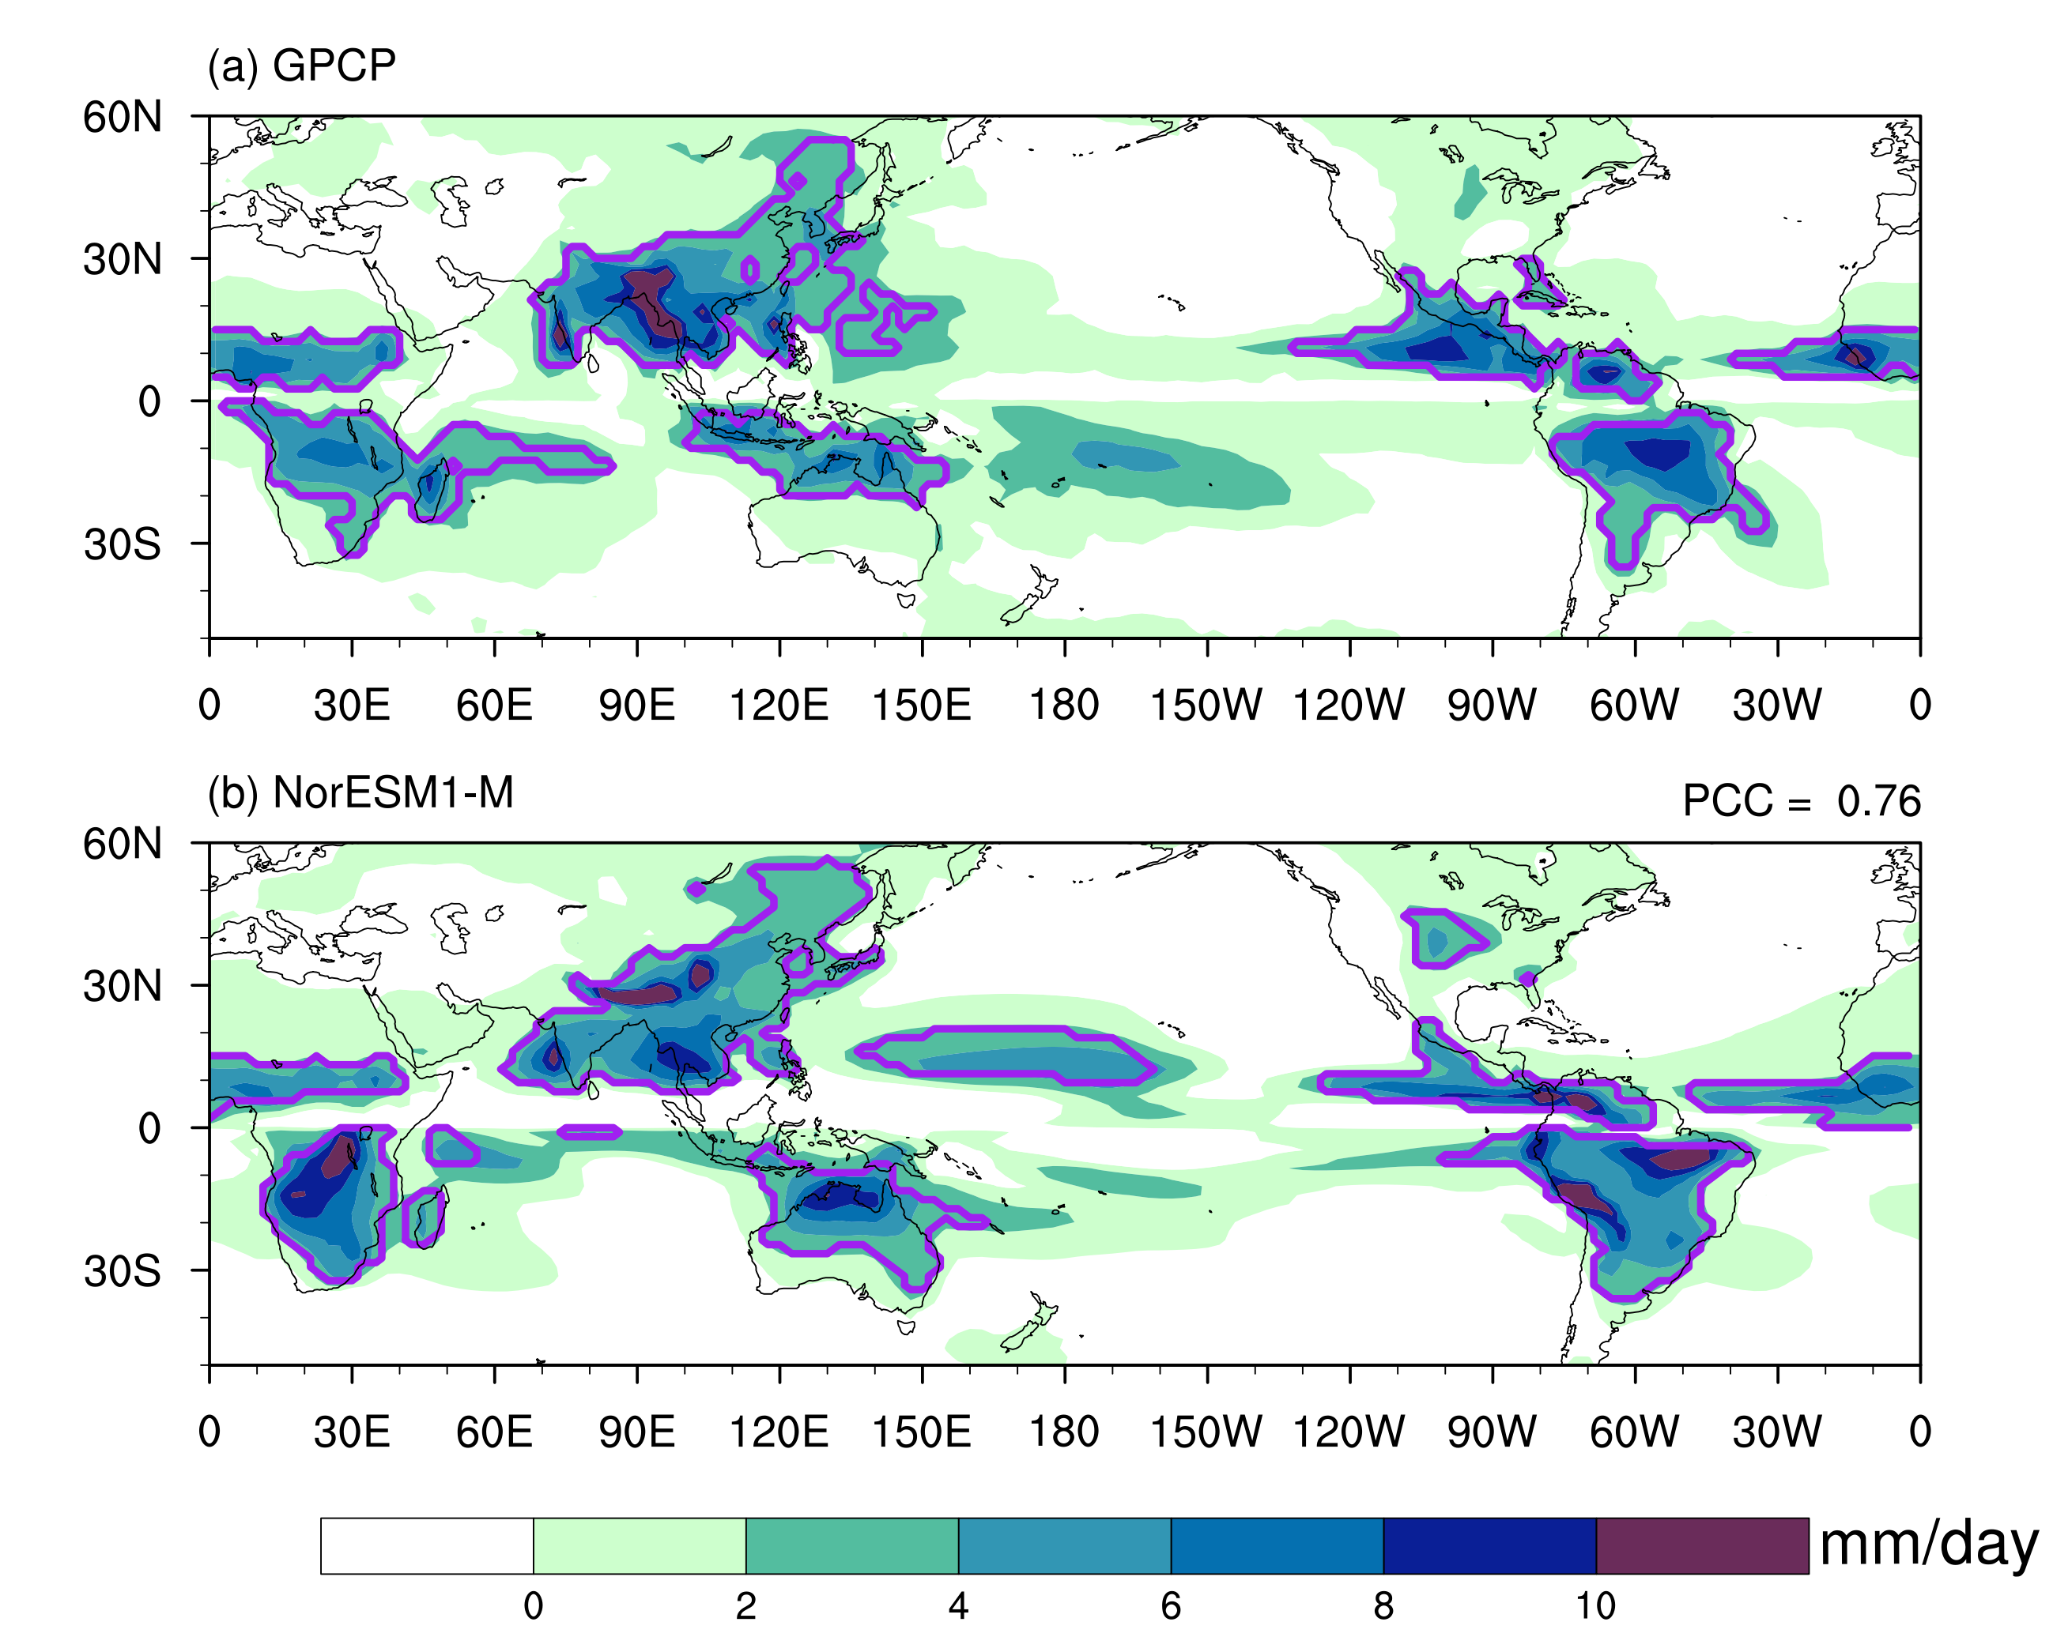
Figure S1: Comparison of global monsoon precipitation intensity and domain between observation (GPCP) and NorESM1-M model simulation. The global monsoon precipitation domain (outlined by purple contours) is defined by regions where the summer-minus-winter precipitation exceeds 2.0 mm day⁻¹ and the summer precipitation exceeds 55% of the annual total, where summer means MJJAS (NDJFM) for the NH (SH). The pattern correlation coefficient (PCC) of global patterns between the observation and simulation is shown in (b).
Figure S2: Uncertainty in GLM precipitation projections in VOLC explained by internal variability (blue) and volcanic uncertainty (pink). The anomalies are calculated relative to the 1995-2014 mean. The components of standard deviation are scaled from the estimated variances according to Hawkins and Sutton (2011) (Supplementary Text S3).

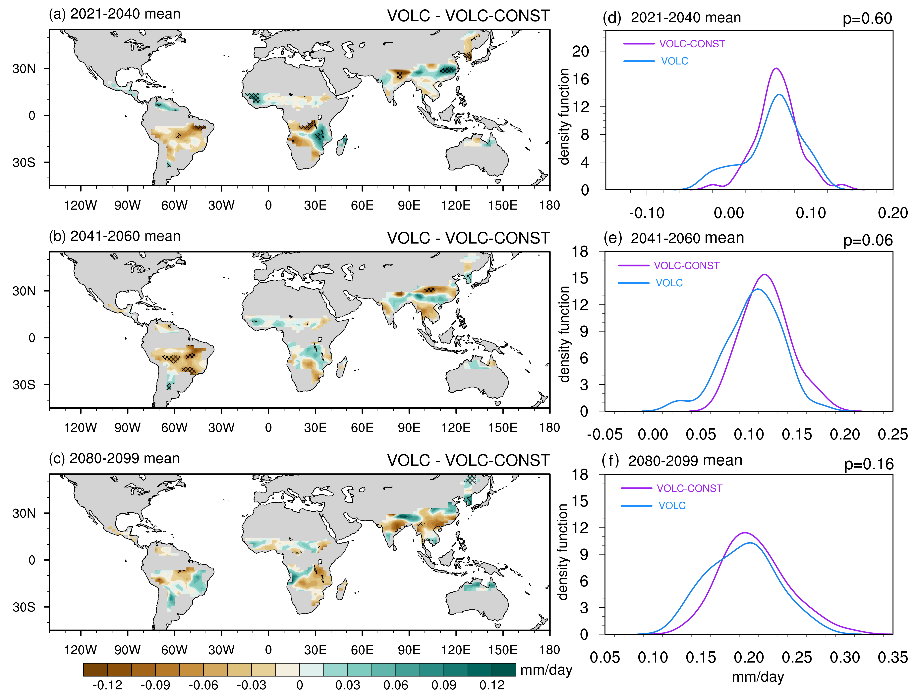
Figure S3: Precipitation difference between VOLC and VOLC-CONST over the GLM domain (units: mm day⁻¹) in the (a) near-term (2021-2040), (b) mid-term (2041-2060), and (c) long-term (2081-2098) projection. The significance levels are determined according to the Student’s t-test, and the slashes indicate the values that are statistically significant at the 5% level. The right panel represents probability density function (PDF) of the GLM precipitation for the (d) near-term (2021-2040), (e) mid-term (2041-2060), and (f) long-term (2081-2098) mean relative to the period 1995-2014. Purple corresponds to VOLC-CONST and blue corresponds to VOLC. Kernel density estimation is used to estimate all the PDFs. The Kolmogorov-Smirnov (KS) test is used to determine the significance of the PDF distributions. The PDF distributions of the GLM precipitation in VOLC and VOLC-CONST are not statistically distinguishable (KS test p values < 0.05) during all three discrete intervals.

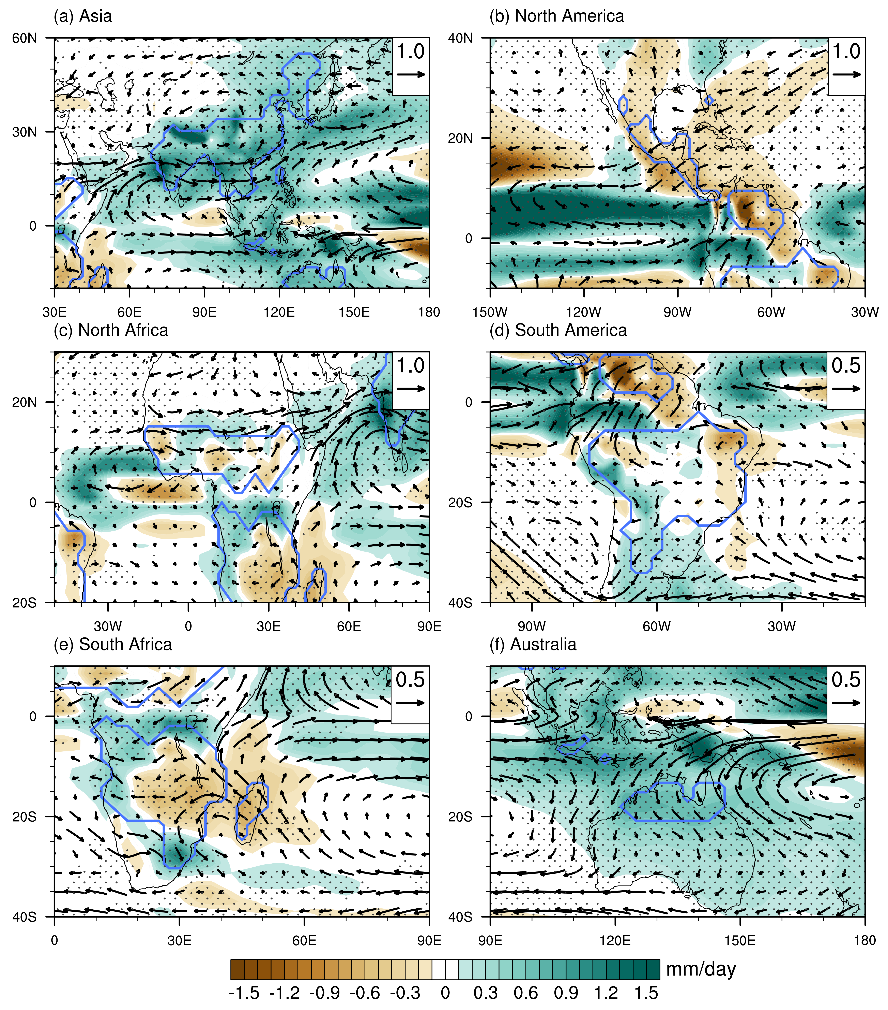
Figure S4: Spatial patterns of the summer (MJJAS in NH and NDJFM in SH) 850-hPa winds (vectors; m/s) and precipitation (shading; mm/day) for the long-term changes (2081-2098 relative to 1995-2014) in the NO-VOLC ensembles. Blue lines represent each land monsoon subdomains. Dots denote areas that are significant at the 5% level by the student’s t test.

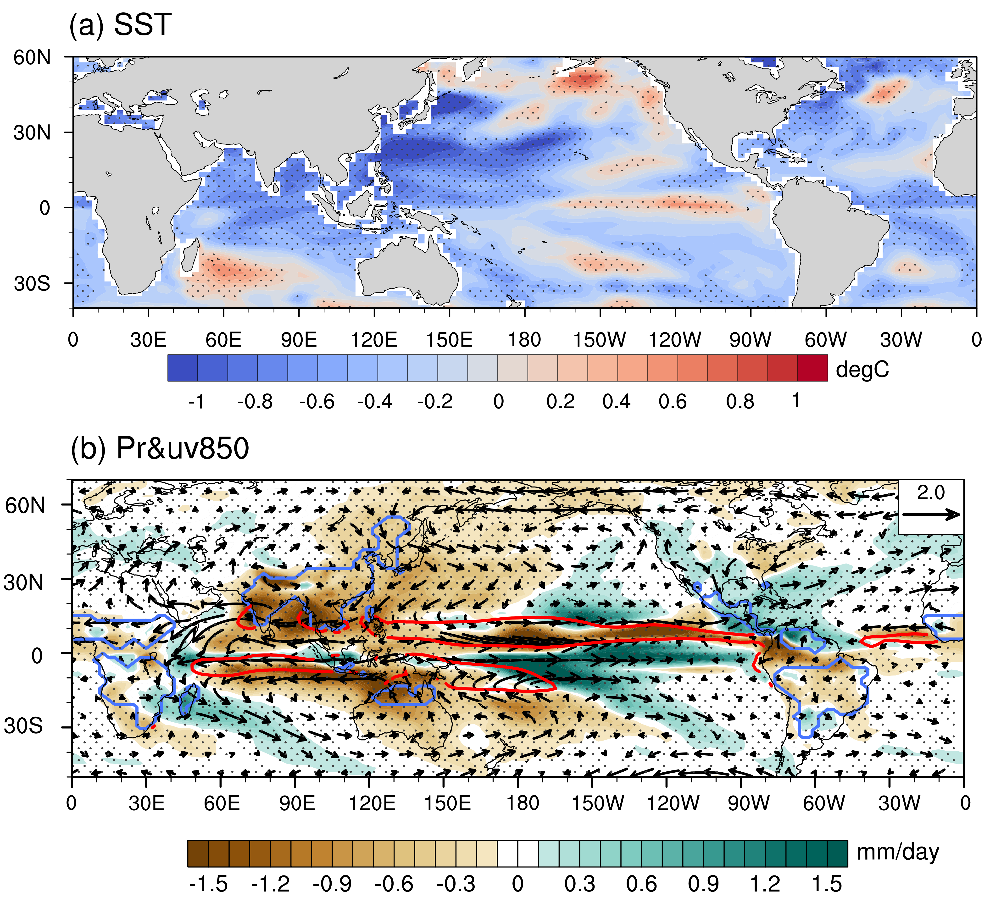
Figure S5: (a) Averaged sea surface temperature (K) anomalies in the local summer of year 0 and year 1 following large volcanic eruptions (with global total sulphate aerosol injection greater than 30Tg) based on the VOLC experiment. (b) The same as (a), but for local summer precipitation and 850hPa wind anomalies, the red lines represent the region with climatological precipitation over 8mm day⁻¹.

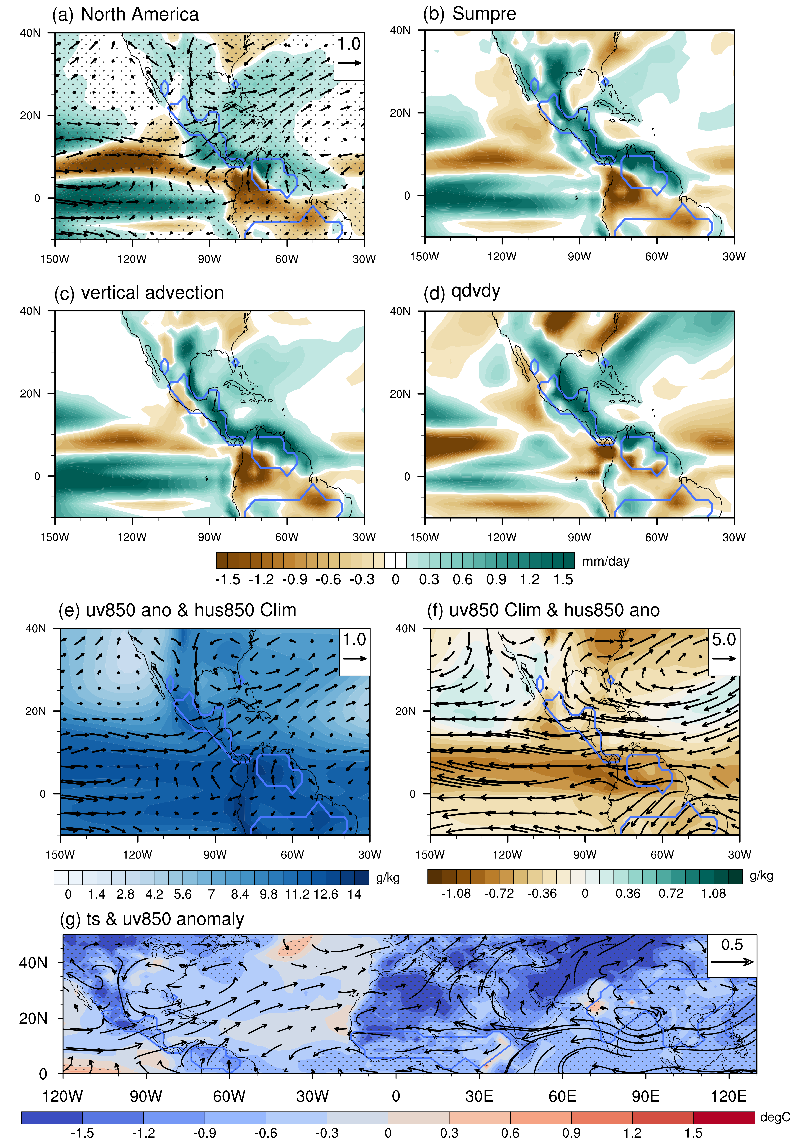
Figure S6: (a) Averaged precipitation (mm day-1) and 850 hPa wind (m s-1) anomalies in the local summer of year 0 and year 1 following large volcanic eruptions (with global total sulphate aerosol injection greater than 30Tg) based on the VOLC experiments. The blue lines represent the North America monsoon region. The significance levels are determined according to the Monte Carlo test, and the values that are significant at the 95% confidence level are dotted. (b) Precipitation anomaly (mm day-1) calculated by the moisture budget decomposition in Seager et al. (2010). (c) The vertical advection (mm day-1) component $(-\int_{0}^{p_{s}}{q∙∇udp})$of the estimated rainfall changes in Seager et al. (2010). (d) The $-<q∂_{y}v>$ component (mm day-1) of vertical advection. (e) 850 hPa climatological specific humidity (shading; g kg-1) and wind (vectors; m s-1) anomalies after volcanic eruptions. (f) 850 hPa climatological wind (vectors; m s-1) and anomalous specific humidity (shading; g kg-1) after volcanic eruptions. (f) Averaged surface temperature (K) and 850 hPa wind (m s-1) anomalies in the local summer of year 0 and year 1 following volcanic eruptions.

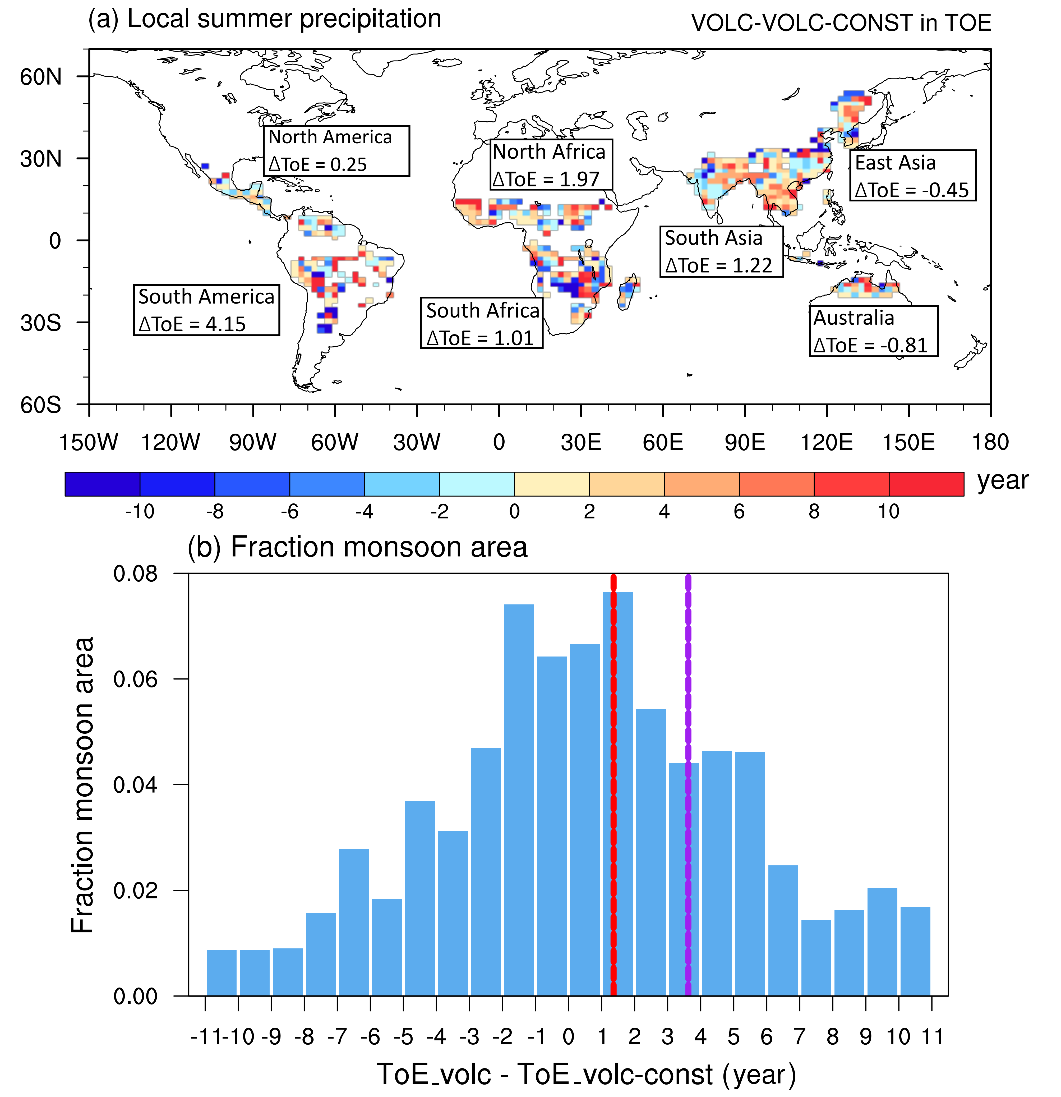
Figure S7: Time of emergence (ToE) of anthropogenic GLM precipitation changes (units: year). (a) ToE difference between VOLC and VOLC-CONST relative to 1995-2014 mean. (b) Fraction monsoon area of ToE difference between VOLC and VOLC-CONST, with dashed lines denoting mean ToE averaged over the whole monsoon region (red) or monsoon region with delayed ToE (purple).

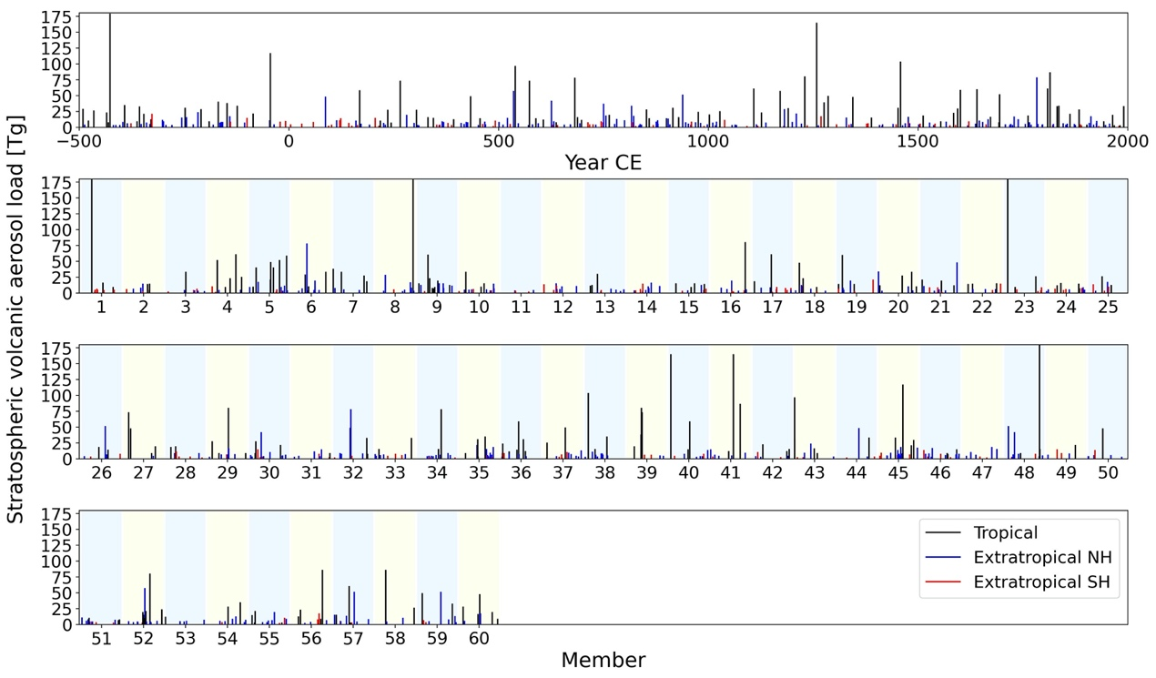
Figure S8: Reconstructed volcanic activity (top panel) from Sigl et al. (2015) versus synthetic volcanic activity used in this study (lower panels).

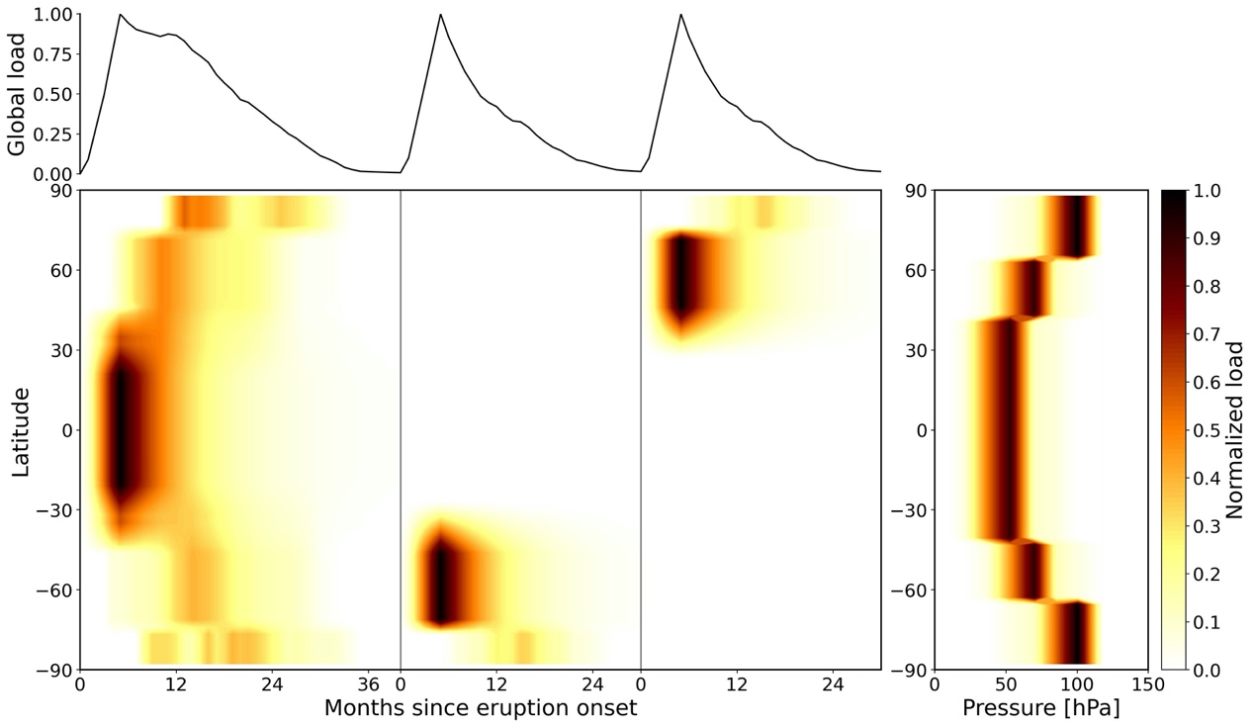
Figure S9: Spatiotemporal shape functions of volcanic forcing according to Bethke et al (2017). Normalized time-latitude (left) and pressure-latitude (right) shape functions.

References
Ammann, C. M., Meehl, G. A., Washington, W. M., & Zender, C. S. (2003). A monthly and latitudinally varying volcanic forcing dataset in simulations of 20th century climate. Geophysical Research Letters, 30, 1657. https://doi.org/10.1029/2003GL16875
Bethke, I., Outten, S., Otterå, O. H., Hawkins, E., Wagner, S., Sigl, M., & Thorne, P. (2017). Potential volcanic impacts on future climate variability. Nature Climate Change, 7(11), 799-805. https://doi.org/10.1038/nclimate3394
Hawkins, E., & Sutton, R. (2009), The potential to narrow uncertainty in regional climate predictions. Bulletin of the American Meteorological Society, 90, 1095-1107. https://doi.org/10.1175/2009BAMS2607.1
Hawkins, E., & Sutton, R. (2011), The potential to narrow uncertainty in projections of regional precipitation change. Climate Dynamics, 37, 407-418. https://doi.org/10.1007/s00382-010-0810-6
Sigl, M., Winstrup, M., McConnell, J. R., et al. (2015). Timing and climate forcing of volcanic eruptions for the past 2,500 years. Nature, 523, 543-549. https://doi.org/10.1038/nature14565
Toohey, M., Stevens, B., Schmidt, H., and Timmreck, C. (2016). Easy Volcanic Aerosol (EVA v1.0): an idealized forcing generator for climate simulations. Geoscientific Model Development, 9, 4049-4070. https://doi.org/10.5194/gmd-9-4049-2016
Zhang, H., & Delworth, T. L. (2018), Robustness of anthropogenically forced decadal precipitation changes projected for the 21st century. Nature Communications, 9(1), 1150. https://doi.org/10.1038/s41467-018-03611-3

